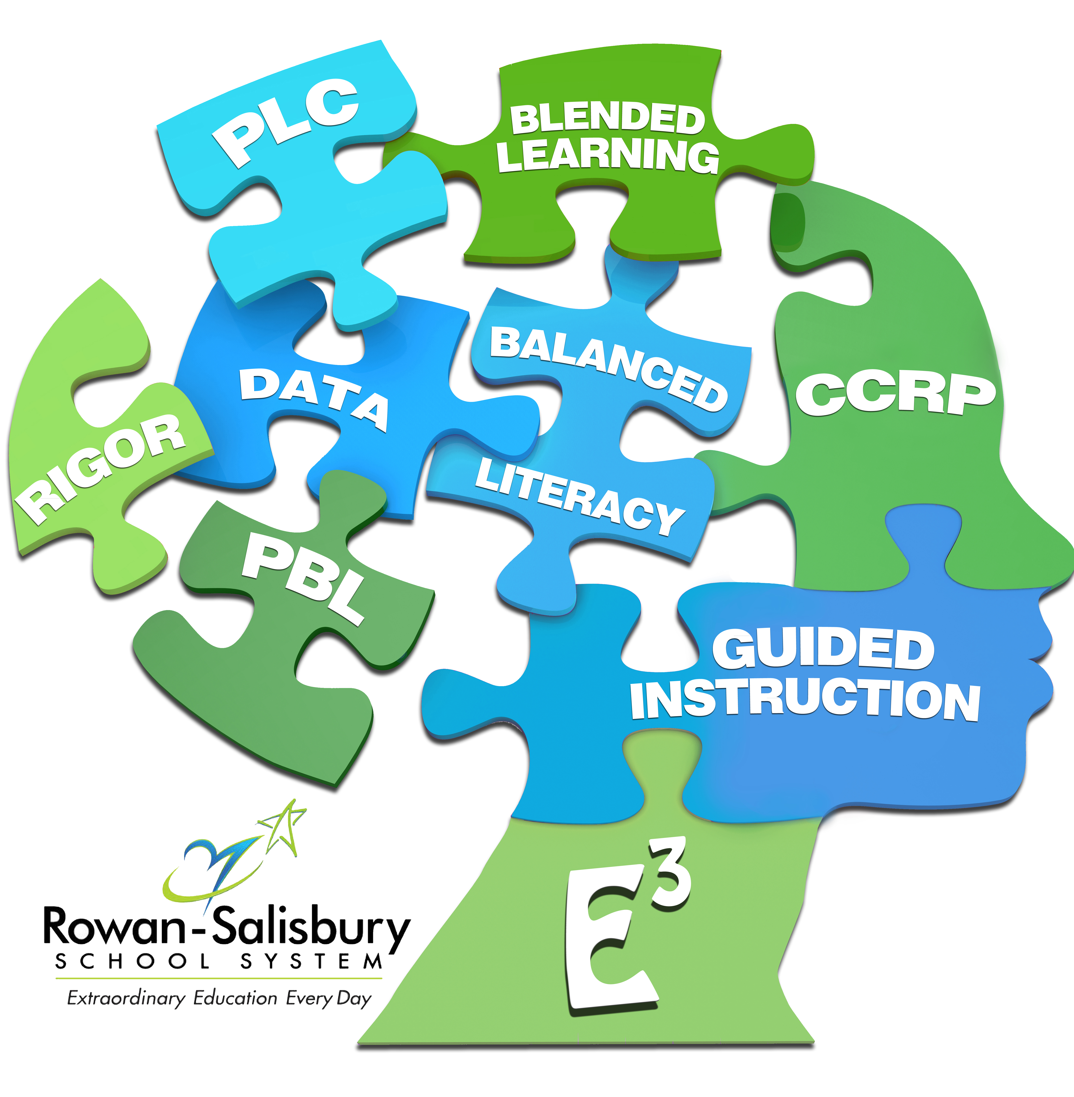

Math 3 Syllabus

This course is designed so that students have the opportunity to expand their knowledge from Math 2. Students will broaden their repertoire of functions to include absolute value, cubic, exponential, logarithmic, polynomial, and rational functions. Students will bring together all of their experience with functions and geometry to create models and solve contextual problems. They will deepen their study of right triangle trigonometry to include the study of trigonometric functions to model simple periodic phenomena and the unit circle. Finally, students will apply methods from statistics to draw inferences and conclusions from data. Appropriate technology and tools, including manipulatives and calculators, will be used regularly for instruction and assessment. This course fulfills the North Carolina high school graduation requirement for Math 3.

NEEDS AND RESOURCES

Required Materials

To successfully complete this course, you will need

- 3-ring binder
- loose leaf paper
- graph paper
- pencil/colored pencil
- laptop
- TI 84 calculator (optional)

Online Resources
- rss.schoology.com
- rss.discoveryeducation.com
- desmos.com

COURSE SCHEDULE

This course covers the given units in the following order. The times given are suggestions plus or minus days at the discretion of the teacher.
- Functions Semester: 10 days
- Inverses, Exponentials, and Logarithms Semester: 9 days
- Polynomial Functions Semester: 10 days
- Rational Functions Semester: 7 days
- Circles Semester: 10 days
- Trigonometric Functions Semester: 10 days
- Two-Dimensional Geometry Semester: 8 days
- Three-Diemensional Geometry Semester: 8 days
- Statistics Semester: 8 days

POLICIES AND PROCEDURES

General Rules:
Classroom Rules:
  - Show respect always
  - Be in the right place at the right time to learn.
  - Be prepared for and focused on learning.

Classroom Consequences:
- Verbal warning/teacher conference
- Change seats or remove from classroom into another classroom
- Parent contact
- Administration referral
Classroom Procedures:
- Students may collaborate on homework and selected classwork assignments. Students will submit their own work for each assignment. Students will complete all assignments in their entirety on the day that assignment or assessment is due.
- Students will be required to complete all readings, video notes, and homework in order to participate in class activities the following class period.
- No cell phones allowed during class
- All students are expected to be on task when the tardy bell rings.
- No talking during quizzes, tests ,and while the teacher is giving instructions and/or notes.
- Teacher will dismiss the class not the bell. All students must be sitting in their seats.
- One student is allowed out of the class at a time with a pass. (bathroom, guidance, etc.)
- No food or drinks allowed in class. Students may have water.
- Stay in seats at all times unless given permission.
- ASK questions (always seek knowledge). Advocate for yourself.
- Tardy: Excessive tardies (3 or more) will result in an administration referral

Grading Policies:
- Late Work: Late work will be accepted with required paperwork. See RSS code of conduct handbook
- Quiz: Quiz grades can be improved if the Unit assessment is higher than the quiz within the unit. The quiz grade will then be replaced with the higher unit test grade, prior to test corrections
- Units with 3 or more quizzes – if you score 80 or higher on each individual quiz you can be exempt from the unit test and the average of the quizzes will be your grade for the test.
- Test: All test are cumulative. Test grades can be improved by completing and turning test corrections, showing all work, before the next unit test. Previous test grades will then be replaced by the next unit test grade (going back only one test) if the previous test corrections are submitted with 100% accuracy.
- Final grade will be based grades for quarter 3 (40%), quarter 4 (40%), and final exam (20%).

GRADING SCALE AND POLICIES
Grading Scale:
A: 90-100
B: 80-89
C: 70-79
D: 60-69

ADDITIONAL INFORMATION

Please contact me with any comments, questions, or concerns. It takes a team for your child/student to be successful. Together Everyoe Achieves More

CONTACT INFORMATION
- Cynthia Coleman
- 704-636-4420 ext 376744
- cynthia.coleman@rss.k12.nc.us
- Tutoring is available Monday - Thursday 4:00- 6:00 in night school or by appointment.

Student: I have read the Math 3 Policies and Expectations and will abide by the rules and expectations listed.

Student Signature: _____________________________________ Date: ______

Printed Student Name: _________________________________

Parent/Guardian: I have read the Math 3 Policies and Expectations and will support its contents and teacher expectations.

Parent Signature: _____________________________________ Date: ______

Printed Parent Name: ______________________________________

Parent/Guardian Contact Information
Curent Addresss:

Home phone: ____________________________

Work Phone: _____________________________

Cell Phone: ______________________________

Email address: ___________________

